Eyeconic - Glasses Shop Management System

Use-Case-Realization Specification: M02-Remove User

Version 1.0

Revision History

|  |  |  |  |
| --- | --- | --- | --- |
| **Date** | **Version** | **Description** | **Author** |
| 20/11/2019 | 1.0 | The first version of remove user | Hoàng Tiến Long |

Table of Contents

1. Introduction 4

1.1 Purpose 4

1.2 Scope 4

1.3 Definitions, Acronyms, and Abbreviations 4

1.4 References 4

1.5 Overview 4

2. Flow of Events—Design 4

3. Derived Requirements 6

Use-Case-Realization Specification: Remove User

# Introduction

## Purpose

This document describes how the Remove User use case is realized within the design model.

## Scope

This document applies to the Eyeconic - Glasses Shop Management System.

## Definitions, Acronyms, and Abbreviations

None.

## References

None.

## Overview

In the following section, Use-Case Realization Specification of the Remove User use-case of the Eyeconic is provided in detail. The first section is a textual description of the Use-Case specification. The following section contains sequence diagrams describing how the use case is realized in terms of collaborating objects. The third section includes class diagrams with relationships that participate in the realization of the use case. The last section is an analysis of all requirements, such as non-functional requirements, on the use-case realization that are not considered in the design model, but that need to be taken care of during implementation.

# Flow of Events—Design

**2.1. Use-Case Specification**

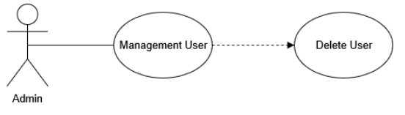

|  |  |  |  |
| --- | --- | --- | --- |
| **Name** | | | Remove User |
| **Brief Dexcription** | | | Administrator removes new users into the website. |
| **Actors** | | | Administrator |
| **Flow of Events** | | | |
| **Basic Flow** | | | |
| Step 1: Click the remove user button in user management.  Step 2: Confirm to delete the user.  Step 3: System displays user management in the website. | | | |
| **Alternative Flows** | | | |
| **Title** | | **Description** | |
| Invalid information entered | | 1. System displays information with appropriate message to correct invalid information. | |
| **Pre-Conditions** | | | |
| None. | | | |
| **Post-Condition**  Administrator checks the database and the website to ensure that the new user is removed successfully. | | | |
| **Title** | **Description** | | |
| Success | Success message is prompted and the user is removed to database. | | |
| Failure | The admin is unable to remove new user to database for one or more reasons and an error is prompt. | | |
| **Extension Points** | None | | |

**2.2. Sequence Diagram**

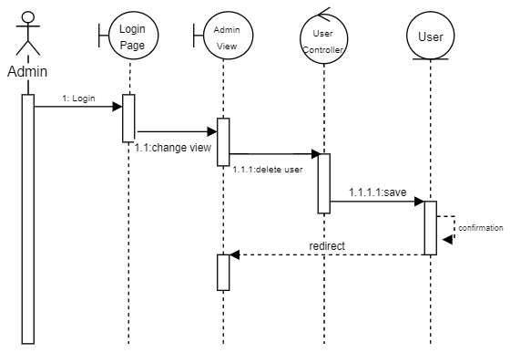

**2.3. Class Diagram**

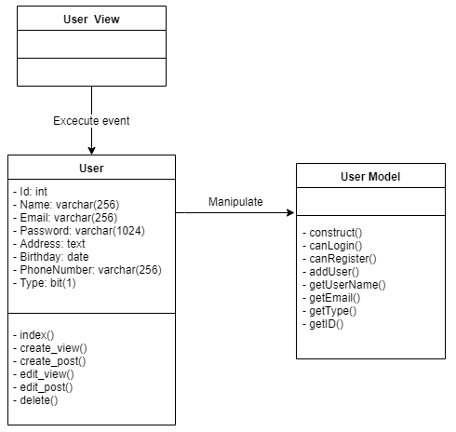

# Derived Requirements

None.